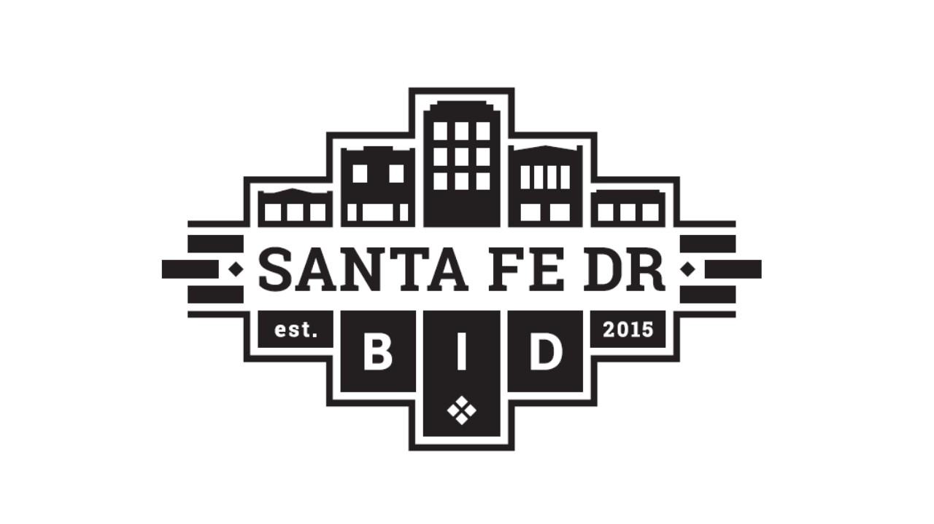
Santa Fe Business Improvement District
Board of Directors Meeting Agenda
July 28, 2026, 3:00 - 5:00 pm
Zoom https://us02web.zoom.us/j/85848565478

Call to Order

Declaration of Quorum | Roll Call
Approval of Agenda and Prior Meeting Minutes
- Motion to approve the agenda and previous meeting minutes
Guests
- Corridor Stakeholders Updates - Open to attending guests, agencies, nonprofits, businesses, and community organizations.
- Guest Presentation – West Denver HUD Neighborhood Revitalization Strategy Area (NRSA) Application Update
  - Presenters: Travon Earl, Director, NRSA & Amelia Hovanec, Denver Economic Development & Opportunity (DEDO)
City/Community Partners & District Updates
- Safety Updates - CRO Officer (OUT TODAY)
- Streetscape Updates
  - Streetscape Construction Update - Tony
  - DEDO Small Business Mitigation Updates - Lauren
  - Denver Water

Committees & BID Partner Reports
- Economic Development & Community Updates
  - Art District on Santa Fe – Lindsey/Ana Paula
  - La Alma Lincoln Park - Nate/Troy

Executive & Organizational Updates
- SFBID Updates – Jackie

Operations & Maintenance Updates
- Maintenance Report – Front Range, Jason or Len

New/Old Business
- Old Business and New Business

Next Meeting
Tuesday, August 25, 2026, 3:00 - 5:00 PM Via Zoom
Adjournment

